Mossel Bay Camera Club
Article Mossel Bay Advertiser Thursday, 09 November 2023, 12:56 and 10 November 2023

The Mossel Bay Camera Club was formed in January this year. In February the club had its first evening meeting It is one of 85 camera clubs in the country, excluding school camera clubs.
The club is affiliated to the Photographic Society of South Africa (PSSA), responsible for the guidelines and standards individuals and clubs should adhere to. The PSSA is also responsible for the training and accreditation of judges, awarding of honours qualifications and providing workshops monthly and competitions annually. A typical PSSA photography year is from 1 July to 30 June the following year.
During 2022-23 the Mossel Bay Camera Club participated in the PSSA interclub competition. There are two categories: Junior Photographer (one to three stars) and Senior Photographer (four stars to masters).
The Mossel Bay Camera club's juniors ended ninth and the seniors 22nd in the competition. The club - juniors and seniors together - came 15th.
This is remarkable, because the club had only been in existence for six months before the closing date for entries to the competition.

Even more remarkable is that the Mossel Bay club came up against respected clubs, such as the Springs Photographic Club, Swartland Fotografieklub, Hermanus Photographic Society, National Photographic Club (Pretoria), Vanderbijlpark Fotografiese Vereniging, Port Elizabeth Camera Club, Tafelberg Fotografieklub, Centurion Camera Club, Pretoria Photographic Society, Tygerberg Photographic Society, Rustenburg Photographic Society, Ballito Photo Club, Nelspruit Photographic Society and also, in the Garden Route, the Eden Photographic Society (EPS).
Fellowship
The Mossel Bay club has two of the most highly qualified photographers in the Garden Route - Verinda Bosch and Anton la Grange – as members.
Bosch has an amazing 20 PSSA honours awards (Read more about her here). Lately, she was rewarded with the Fellowship of the Photographic Society of South Africa (FPSSA) after she presented a portfolio of 25 photographs to a judging panel. The FPSSA "is awarded for excellence and distinguished ability. The fellowship recognises a high standard of achievement in the art and science of the medium and is awarded for excellence".
Bosch has also received three DPSSA(Cls) awards for each of her 250 acceptances for the categories Monochrome, Colour Open and Nature. Because she has received three, she qualifies for her DPSSA(Cls Vers) and is the first person who has ever received this accolade. Bosch has also received her EPSSA(Cls) for 750 salon acceptances and her EPSSA (Mille) for 1 000 salon acceptances.
The Mossel Bay Camera Club is extremely proud of Bosch, who not only rakes in the awards and is highly prolific, but she continues to inspire other club members to hone their skills.
Anton la Grange, chairperson of the camera club, who is a PSSA director, has 10 PSSA honours awards including a FPSSA, three DPSSA (Cls) awards, DPSSA (vers) and EPSSA (Cls). Read more about him here.

 | 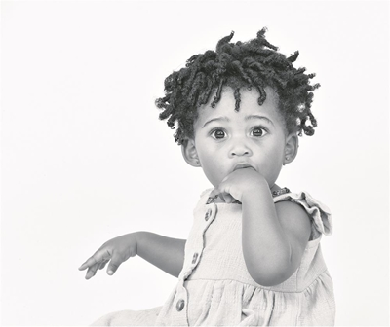
Photo: Anton La Grange | Photo: Verinda Bosch
Photo: Elaine van der Toorn. | Photo: Tilla Vorster.

