BOKSBURG CAMERA CLUB -
Introducing our youngest photographer – 8-year-old Alexis Koekemoer
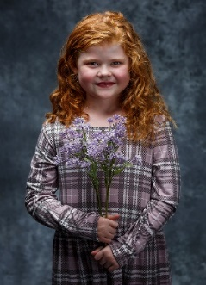
This avid young photographer joined the club as a 1 Star member in January 2024. To date (August 2024) she has progressed to 2 Star, achieved 4 (out of 5) acceptances in her first salon attempt and has consistently won open and set subject categories in club monthly competitions.
Alexis is in Grade 2 at Elspark Laerskool and has been taking photos since the end of her third year. She received her first camera at the tender age of four and has progressed in leaps and bounds from there. Having been exposed to the camera club scenario from when she was a baby, Alexis learned all about exposure, focus, composition etc. as a natural progression. From the early stages of her life, she also quickly learned how to practically apply her learning, producing great photos.
This young lady knows her own mind when it comes to her photography and does all but the most complex editing of her own photos and is very sure of which of her photos are to be entered into monthly competitions. Alexis is determined to enter her photos as she thinks best and frequently proves that she is right by the results she achieves, as per the examples shown below.
Boksburg Camera Club is extremely proud of our youngest member, and we believe that she has a very bright future photographically speaking.
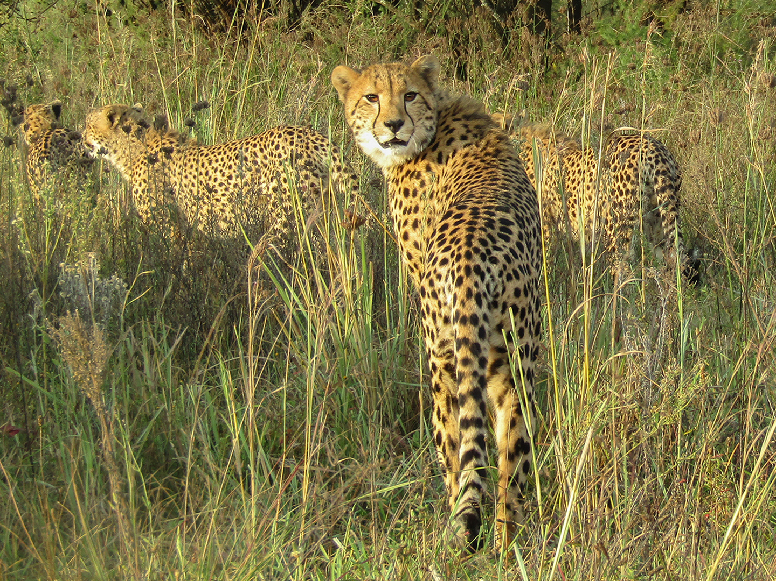
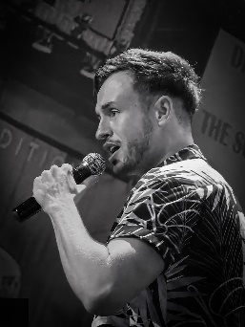 | 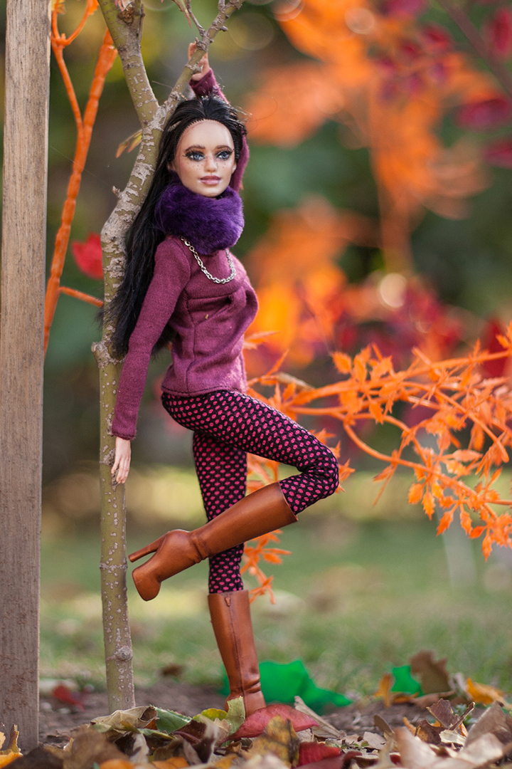
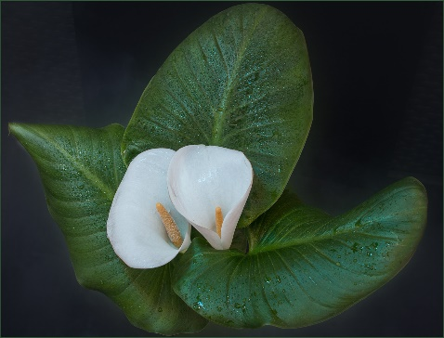

Written August 2024 by Barry Clayton.

